DAYANANDA SAGAR UNIVERSITY
Devarakaggalahalli, Harohalli Kanakapura Road, Dt, Ramanagara, Karnataka 562112



DEPARTMENT OF COMPUTER SCIENCE AND ENGINEERING
(Artificial Intelligence and Machine Learning)

MLOPS (23AM3606)
Project Report on

“Whole Body Diagnosis System with MLOps Pipeline”

By
ABISHEK.A (ENG23AM0100)
VIJAY KUMAR (ENG23AM0085)
PRAJWAL BIRADAR (ENG24AM1005)

Under the supervision of

Prof.Amrita Kundu (AIML – 6D)
Assistant Professor, Artificial Intelligence & Machine Learning, SOE

2025-2026

TABLE OF CONTENTS

S.No | Topic | Page No
- | Abstract | 3
- | SDG Goals | 4
1 | Introduction | 5
2 | Problem statement | 5
3 | Objectives | 6,7
4 | Literature review | 7
5 | Project description | 7
6 | Methodology | 8,9
7 | Expected Results | 10
8 | Conclusion | 10
- | References | 11,12

ABSTRACT

This project presents an end-to-end MLOps-enabled Whole Body Diagnosis System designed to screen patients for four major chronic diseases - Diabetes, Chronic Kidney Disease (CKD), Chronic Liver Disease (CLD), and Heart Disease using machine learning models deployed through a production-grade MLOps pipeline. The system combines Random Forest classifiers trained on clinically validated datasets with a robust MLOps infrastructure encompassing data versioning via DVC, experiment tracking via MLflow, explainability via SHAP, drift monitoring via Evidently AI, containerized deployment via Docker, automated CI/CD via GitHub Actions, and a scalable REST API built with FastAPI. The models achieve accuracies of 93.27%, 97.50%, 99.32%, and 91.53% for Diabetes, CKD, CLD, and Heart Disease respectively. The proposed system bridges the gap between machine learning research and production deployment by automating the full ML lifecycle from data ingestion to monitoring and retraining.
SDG GOALS:
This project contributes to the following United Nations Sustainable Development Goals (SDGs):
- SDG 3: Good Health and Well-Being - Early AI-based detection of major diseases helps reduce deaths and improve health.
- SDG 9: Industry, Innovation, and Infrastructure – The project builds a scalable and modern AI healthcare system using advanced technologies.
- SDG 10: Reduced Inequalities – It provides equal access to disease screening for people in both urban and rural areas..
- SDG 17: Partnerships for the Goals – The system uses open-source tools and shared data to support global collaboration.

1. INTRODUCTION:
Artificial Intelligence is increasingly transforming healthcare by enabling early detection and prediction of life-threatening diseases. This project presents a Whole Body Diagnosis System that uses machine learning models to identify conditions such as Diabetes, Chronic Kidney Disease, Chronic Liver Disease, and Heart Disease from routine clinical data. By leveraging powerful algorithms like Random Forest, the system provides accurate and interpretable predictions. To ensure real-world usability, the project integrates a complete MLOps pipeline with tools for data versioning, experiment tracking, model monitoring, and deployment. The system is designed to be scalable, reliable, and accessible through a REST API, making advanced disease screening available even in resource-limited settings.

2. PROBLEM STATEMENT:
Machine learning has shown great potential in medical diagnosis, but most systems remain limited to research and are not used in real-world healthcare. Many existing solutions lack reproducibility, proper monitoring, and explainability, making them unreliable for clinical use. In addition, deployment is often manual, error-prone, and difficult to scale for multiple users. These systems also fail to handle data drift or support automatic retraining, which reduces their long-term effectiveness. There is a need for a robust, scalable, and production-ready solution that addresses these challenges. This project solves these issues by building a complete MLOps-based disease diagnosis system that is reliable, explainable, and suitable for real-world healthcare deployment.

3. OBJECTIVES:
3.1 Develop Disease Prediction Models

Build accurate machine learning models to detect Diabetes, Chronic Kidney Disease, Chronic Liver Disease, and Heart Disease using minimal and commonly available clinical data.

3.2 Build an End-to-End MLOps Pipeline

Create a complete pipeline integrating tools like DVC, MLflow, and Optuna for data versioning, experiment tracking, model management, and automated tuning.

3.3 Deploy as a Scalable API

Develop a production-ready REST API using FastAPI with proper input validation and interactive documentation for easy usage.

3.4 Ensure Reproducibility with Containerization

Use Docker to package the entire application, ensuring consistent performance across different environments.

3.5 Provide Model Explainability

Integrate SHAP to explain model predictions, helping doctors understand how each feature contributes to the diagnosis.

3.6 Monitor Model Performance

Implement data drift detection using Evidently AI and enable automatic retraining when performance drops.

3.7 Automate CI/CD Pipeline

Set up continuous integration and deployment using GitHub Actions to automate testing, building, and deployment.
3.8 Provide Model Explainability

Assess models using key metrics like accuracy, precision, recall, F1-score, and ROC-AUC, with all results tracked in MLflow.

4. LITERATURE REVEIW:
Machine learning has been widely used in healthcare for early disease detection, with models like Random Forest (by Leo Breiman) showing strong accuracy. Techniques like SMOTE help handle imbalanced medical data, while explainability methods such as SHAP make predictions understandable for doctors.MLOps tools like MLflow and DVC improve reproducibility and management of ML systems. Additionally, technologies like Docker and GitHub Actions enable reliable deployment and automation. This project builds on these advancements to create a scalable and production-ready healthcare diagnosis system. Furthermore, monitoring and maintenance have become essential in real-world ML systems. Tools like Evidently AI help detect data drift and ensure models continue to perform accurately over time, while hyperparameter optimization frameworks like Optuna improve model performance efficiently. These developments highlight the importance of combining machine learning with strong engineering practices, which this project successfully demonstrates.

5. PROJECT DESCRIPTION:
The Whole Body Diagnosis System is an AI-based healthcare platform designed to detect multiple chronic diseases—Diabetes, Chronic Kidney Disease, Chronic Liver Disease, and Heart Disease—using simple clinical inputs such as blood test values. It uses optimized Random Forest models trained on public datasets to provide accurate and reliable predictions. The system is built as a complete MLOps pipeline, integrating MLflow for experiment tracking, DVC for data versioning, and SHAP for model interpretability. It is deployed as a scalable REST API using FastAPI and containerized with Docker to ensure consistent deployment across environments. The system also includes monitoring with Evidently AI for detecting data drift and automated CI/CD using GitHub Actions, making it a reliable, scalable, and production-ready solution for real-world healthcare diagnosis.

6. METHODOLOGY:
1.Data Collection - Collected four datasets (Diabetes, CKD, CLD, Heart Disease) from Kaggle and UCI.

2.Data Preprocessing - Filled missing values, converted categorical data, and scaled numerical features.

3.Feature Selection - Selected the most important features using Random Forest importance scores.

4.Class Balancing - Used SMOTE to handle imbalanced data and improve prediction accuracy.

5.Hyperparameter Tuning - Used Optuna to find the best model parameters.

6.Model Training - Trained Random Forest models with optimized parameters.

7.Experiment Tracking - Used MLflow to track all experiments and results.

8.Model Registration - Saved the best models in MLflow for easy management and reuse.

9.Model Explainability - Used SHAP to understand how models make predictions.

10.API Development - Built a REST API using FastAPI for predictions.

11.Containerization - Used Docker to package the application.
12.CI/CD Pipeline - Automated testing and deployment using GitHub Actions.

13.Drift Monitoring - Used Evidently AI to detect changes in data and maintain model performance.
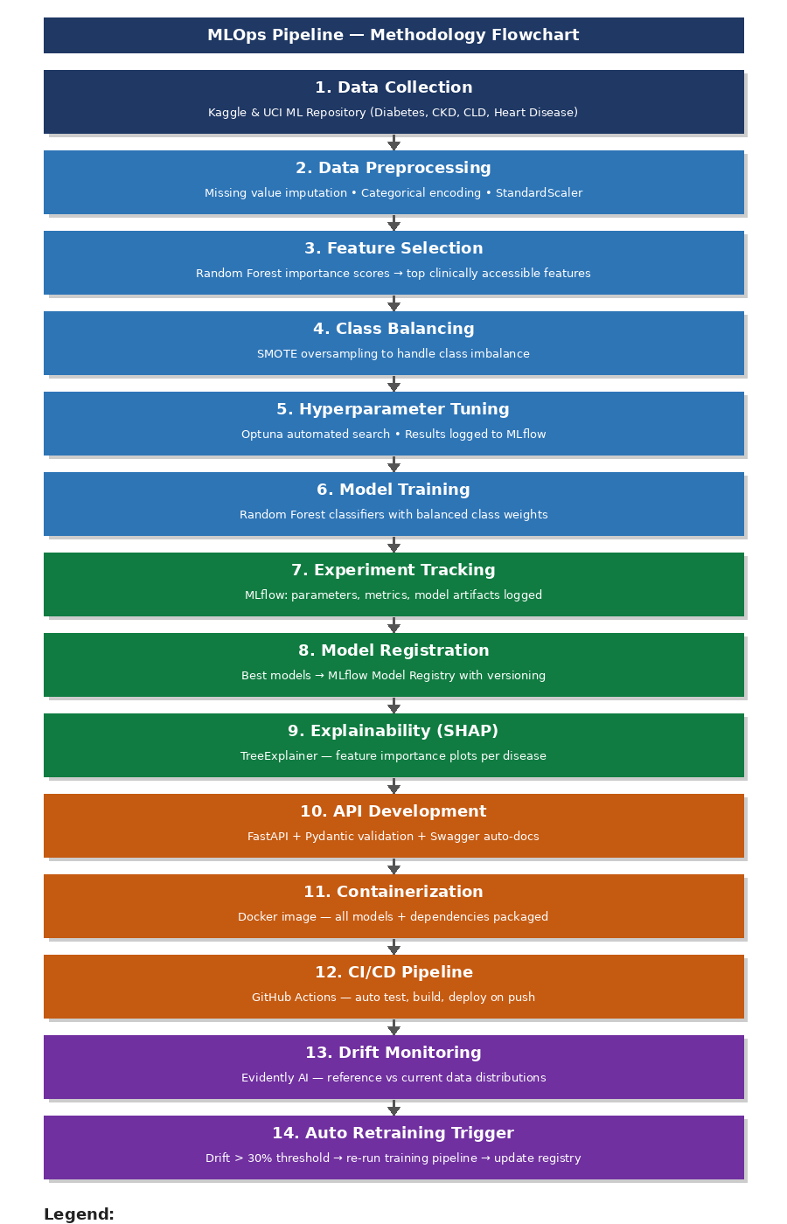
7. EXPECTED RESULTS:
Based on the implemented methodology, the following outcomes are expected upon project completion:

- Four trained Random Forest classifiers achieving test accuracies exceeding 91% for all diseases, with ROC-AUC scores exceeding 87% across all models, deployed as live REST API endpoints.
- High accuracy disease prediction models deployed as API
- Experiment tracking and reproducibility using MLflow and DVC
- Model explainability using SHAP
- Automated deployment with GitHub Actions and Docker
- Data drift detection and automatic model retraining

8. CONCLUSION:
This project successfully develops an AI-based Whole Body Diagnosis System using machine learning and a complete MLOps pipeline. It combines accurate disease prediction models with tools like MLflow, DVC, FastAPI, and Docker to create a reliable and scalable healthcare solution. The system helps in early detection of major diseases, making healthcare more accessible and efficient. It also supports real-world deployment through automation, monitoring, and explainability. In the future, the system can be improved by adding more diseases, using real-time hospital data, and enhancing privacy and clinical validation, making it even more useful in practical healthcare applications.

REFERENCES:
1. Sculley, D., Holt, G., Golovin, D., Davydov, E., Phillips, T., Ebner, D., Chaudhary, V., Young, M., Crespo, J., & Dennison, D. (2015). Hidden Technical Debt in Machine Learning Systems. Advances in Neural Information Processing Systems (NIPS), 28, 2503–2511.

2. Lundberg, S. M., & Lee, S. I. (2017). A Unified Approach to Interpreting Model Predictions. Advances in Neural Information Processing Systems (NIPS), 30, 4765–4774.

3. Zaharia, M., Chen, A., Davidson, A., Ghodsi, A., Hong, S. A., Konwinski, A., Murching, S., Nykodym, T., Ogilvie, P., Parkhe, M., Xie, F., & Zumar, C. (2018). Accelerating the Machine Learning Lifecycle with MLflow. IEEE Data Engineering Bulletin, 41(4), 39–45.

4. Kreuzberger, D., Kuhl, N., & Hirschl, S. (2023). Machine Learning Operations (MLOps): Overview, Definition, and Architecture. IEEE Access, 11, 31866–31879.

5. Rajpurkar, P., Chen, E., Banerjee, O., & Topol, E. J. (2022). AI in Health and Medicine. Nature Medicine, 28(1), 31–38.

6. Breiman, L. (2001). Random Forests. Machine Learning, 45(1), 5–32.

7. Chawla, N. V., Bowyer, K. W., Hall, L. O., & Kegelmeyer, W. P. (2002). SMOTE: Synthetic Minority Over-sampling Technique. Journal of Artificial Intelligence Research, 16, 321–357.

8. Akiba, T., Sano, S., Yanase, T., Ohta, T., & Koyama, M. (2019). Optuna: A Next-generation Hyperparameter Optimization Framework. Proceedings of the 25th ACM SIGKDD International Conference on Knowledge Discovery and Data Mining, 2623–2631.

9. Iterative. (2020). DVC: Data Version Control — Git for Data and Models. Retrieved from https://dvc.org

10. Evidently AI. (2021). Evidently: Open-Source ML Monitoring and Observability. Retrieved from https://evidentlyai.com

11. Ribeiro, M. T., Singh, S., & Guestrin, C. (2016). 'Why Should I Trust You?': Explaining the Predictions of Any Classifier. Proceedings of the 22nd ACM SIGKDD International Conference on Knowledge Discovery and Data Mining, 1135–1144.

12. Molnar, C. (2020). Interpretable Machine Learning: A Guide for Making Black Box Models Explainable. Leanpub. Retrieved from https://christophm.github.io/interpretable-ml-book/

13. Bayram, F., Ahmed, B. S., & Kassler, A. (2022). From Concept Drift to Model Degradation: An Overview on Performance-Aware Drift Detectors. Knowledge-Based Systems, 245, 108632.
14. Merkel, D. (2014). Docker: Lightweight Linux Containers for Consistent Development and Deployment. Linux Journal, 2014(239), Article 2.

15. Amershi, S., Begel, A., Bird, C., DeLine, R., Gall, H., Kamar, E., Nagappan, N., Nushi, B., & Zimmermann, T. (2019). Software Engineering for Machine Learning: A Case Study. Proceedings of the 41st IEEE/ACM International Conference on Software Engineering (ICSE), 291–300.

16. Fernandez, A., Garcia, S., Herrera, F., & Chawla, N. V. (2018). SMOTE for Learning from Imbalanced Data: Progress and Challenges, Marking the 15-Year Anniversary. Journal of Artificial Intelligence Research, 61, 863–905.

17. Shankar, S., Garcia, R., Hellerstein, J. M., & Parameswaran, A. G. (2022). Operationalizing Machine Learning: An Interview Study. arXiv preprint arXiv:2209.09125.

18. Fowler, M., & Foemmel, M. (2006). Continuous Integration. Addison-Wesley. Retrieved from https://martinfowler.com/articles/continuousIntegration.html

19. Chen, T. Y. H., Peng, L., Xu, Y., & Zhang, Y. (2020). Towards Continuous Delivery for Machine Learning Systems. Proceedings of the 42nd International Conference on Software Engineering Workshops (ICSEW), 542–547.

20. 1Kaggle. (2023). Heart Disease Dataset,Diabetes Dataset, Chronic Kidney Dataset and Liver Disease Dataset Retrieved from https://www.kaggle.com

